Ensuring Safety Through Machine Learning in Mushroom Edibility Identification

K.V.D.T.N.KARAWITA, W.HASHINI JAYATHUNGA, K.SHIVASHANKARI. S.S.M.HETTIARACHCHI
Department of Bioinformatics, Institute of Molecular Biology and Biochemistry, University of Colombo

Abstract:

Introduction:
Accurately distinguishing between edible and poisonous mushrooms is crucial for ensuring human health and safety. In Sri Lanka, a country rich in diverse wild mushrooms, indigenous communities rely on traditional knowledge for the consumption of these mushrooms. However, the misidentification of mushrooms can have severe consequences, including organ failure and even death. To address this critical issue, machine learning offers a potential solution.

Machine learning models, fueled by algorithms and extensive datasets containing mushroom characteristics, can effectively differentiate between edible and poisonous varieties based on human observations. By inputting physical attributes such as cap color, stem shape, and spore print, these models can analyze the data and make highly accurate predictions. This technology facilitates rapid and reliable mushroom identification, empowering individuals with limited mycological expertise to make informed decisions about mushroom edibility.

By leveraging machine learning, the risk associated with consuming wild mushrooms can be significantly reduced. In essence, this technology plays a vital role in enhancing human safety and well-being by improving the accuracy of mushroom classification.

Project Scope:
Mushrooms hold great popularity as a culinary delight within communities, particularly in tropical regions that boast a rich diversity of wild mushrooms with significant pharmaceutical and nutraceutical value. However, the presence of poisonous mushrooms in this array poses a risk, as people often struggle with accurate identification. To mitigate the potentially life-threatening consequences of consumption, the goal is to create a user-friendly machine learning model. This model is designed for individuals without technical expertise, relying on various physical characteristics such as cap color, odor, cap shape, etc., to enhance accurate mushroom identification.
Main Objective:
Develop a machine learning model for the preliminary identification of mushrooms as either edible or poisonous based on their physical characteristics.
Specific Objectives:
- Collect relevant data from the US Irvine Machine Learning Repository, focusing on physical characteristics.
- Evaluate and choose suitable machine learning algorithms to produce binary output (0/1) indicating whether a mushroom is edible or poisonous.
- Analyze the significance of different physical characteristics (cap color, gill color, spore print color, odor, etc.) to identify the most indicative features in edible mushrooms.
- Discuss the future potential of developing the model into a mobile application, providing assistance to mushroom enthusiasts in identifying edible and poisonous mushrooms.

Methodology:
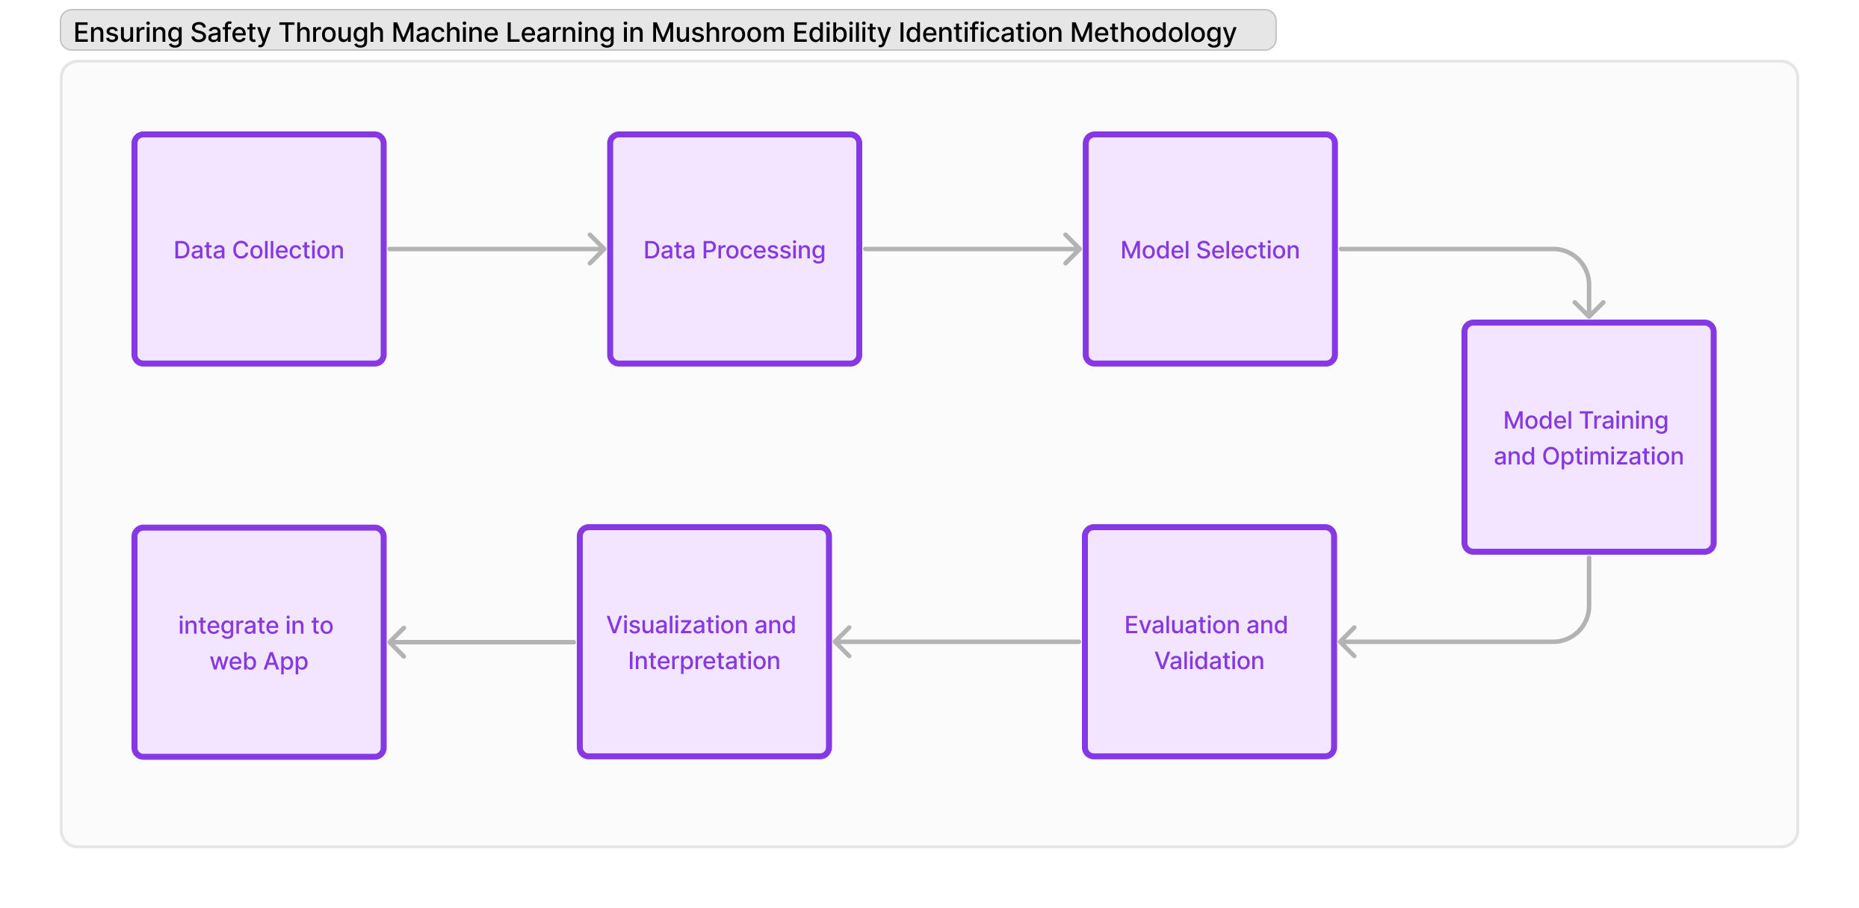

Data Exploration and Analysis:
The data for this project will be sourced from the Mushroom dataset in the UCI Machine Learning Repository. This dataset comprises details of 22 different physical characteristics from 8,124 samples belonging to the Agaricus and Lepiota families. The variables encompass features like cap shape, cap surface, cap color, bruises, odor, gill attachment, gill spacing, gill size, stalk shape, stalk root, stalk surface above ring, stalk surface below ring, stalk color above ring, stalk color below ring, veil type, veil color, ring number, ring type, spore print color, population, and habitat. The class label in the dataset indicates the edibility of the mushrooms, categorizing them as either edible or poisonous.

Model Development:

Model Evaluation:

Results and Findings:

Discussion:

Contributions:

Challenges and Lessons Learned:

References:

